**Semester 1 (Unit 3) Examination, 2020**

**Question/Answer Booklet**

**MATHEMATICS METHODS**

**Section Two: Calculator-assumed**

Student Name/Number: ______________________________________________

Teacher Name: ______________________________________________

**Time allowed for this section**

Reading time before commencing work: ten minutes

Working time for this section: one hundred minutes

**Materials required/recommended for this section**

**To be provided by the supervisor:** This Question/Answer Booklet

Formula Sheet

**To be provided by the candidate:**

Standard items: pens (blue/black preferred), pencils (including coloured), sharpener,

correction fluid/tape, eraser, ruler, highlighters

Special items: drawing instruments, templates, notes on two unfolded sheets of A4 paper, and up to three calculators approved for use in this examination

**Important note to candidates**

No other items may be taken into the examination room. It is **your** responsibility to ensure that you do not have any unauthorised notes or other items of a non-personal nature in the examination room. If you have any unauthorised material with you, hand it to the supervisor **before** reading any further.

**Structure of this paper**

|  |  |  |  |  |  |
| --- | --- | --- | --- | --- | --- |
| Section | Number of questions available | Number of questions to be answered | Working time (minutes) | Marks available | Percentage of exam |
| Section One: Calculator-free | 7 | 7 | 50 | 50 | 35 |
| Section Two: Calculator-assumed | 12 | 12 | 100 | 100 | 65 |
|  | | | | | 100 |

**Instructions to candidates**

1. The rules for the conduct of School exams are detailed in the School/College assessment policy. Sitting this examination implies that you agree to abide by these rules.
2. Write your answers in this Question/Answer booklet preferably using a blue/black pen. Do not use erasable or gel pens.
3. You must be careful to confine your answer to the specific question asked and to follow any instructions that are specified to a particular question.
4. Show all your working clearly. Your working should be in sufficient detail to allow your answers to be checked readily and for marks to be awarded for reasoning. Incorrect answers given without supporting reasoning cannot be allocated any marks. For any question or part question worth more than two marks, valid working or justification is required to receive full marks. If you repeat any question, ensure that you cancel the answer you do not wish to have marked.
5. It is recommended that you do not use pencil, except in diagrams.
6. Supplementary pages for planning/continuing your answers to questions are provided at the end of this Question/Answer booklet. If you use these pages to continue an answer, indicate at the original answer where the answer is continued, i.e. give the page number.
7. The Formula sheet is not to be handed in with your Question/Answer booklet.

**Section Two: Calculator-assumed (100 Marks)**

This section has **12** questions. Answer **all** questions. Write your answers in the spaces provided. Spare pages are included at the end of this booklet.

Suggested working time: **100 minutes**.

**Question 8 (5 marks)**

A certain type of chemical compound contains radioactive isotopes of a particular chemical element. The concentration *c%* of each isotope t years from now is given by a formula of the form

 where $A$ and $k$ are constants.

The half-life of isotope  is 36.5 years, and its present concentration in the compound is 0.03%. The half-life of isotope B is 62.9 years, and its present concentration is 0.02%.

(a) Show that for isotope , (to 3 decimal places). (3 marks)

(b) When will the concentration of isotope B be twice that of isotope  ? (2 marks)

**Question 9 (9 marks)**

A group of medical researchers is investigating the spread of the H2C2 virus in a province by

keeping track of *P*, the population of people infected, *t* weeks after the virus is first

discovered.

Initially, 50 people are infected with the virus. It is suspected that *P* and *t* are related by the

differential equation

 where *K* is a constant.

(a) Determine an expression for the population of people infected, *P*, in terms of *t* and *K*.

(2 marks)

(b) What happens to the population of infected people when:

1. *K* = 1? (1 mark)
2. *K* = 0? (1 mark)
3. On the axes provided below draw a sketch to illustrate the two cases considered.

ie when *K* = 1 and when *K* = 0. (2 marks)

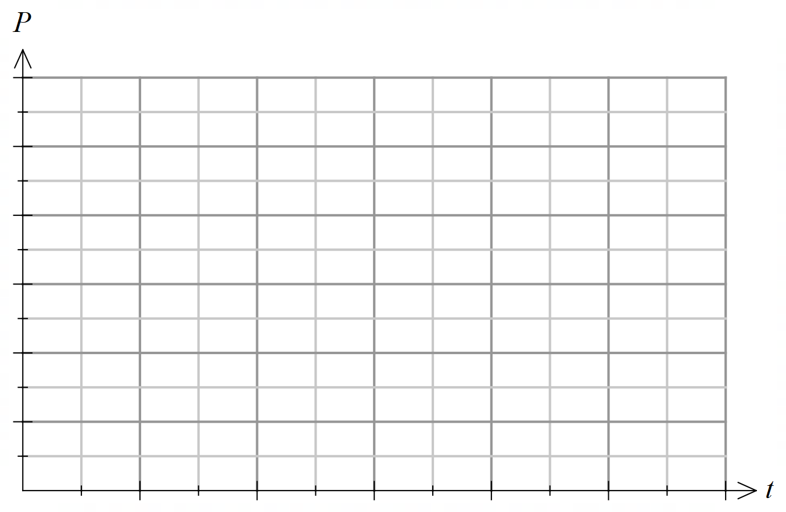

(c) Given that one week later the population of infected people reduces to half of its initial

number, predict what will eventually happen to the population of infected people?

(3 marks)

**Question 10 (6 marks)**

A window consists of an equilateral triangle sitting on top of a rectangle, as shown in the diagram below. The sides of the rectangle are *x* metres and *y* metres. It is also known that the perimeter of the window is 10 metres.

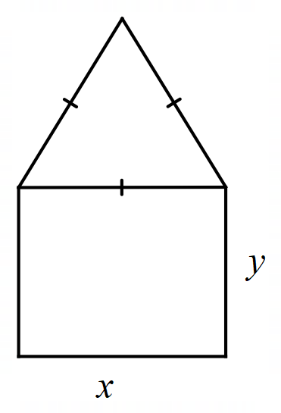

(a) Show that the area of the window, *A* is given by

 (3 marks)

(b) Determine the maximum possible area of the window. (3 marks)

**Question 11 (8 marks)**

The probability distribution of the discrete random variable is shown in the table below.

The expected value of is 3.5.

|  |  |  |  |  |  |
| --- | --- | --- | --- | --- | --- |
| *x* | 0 | 1 | 3 | 4 | *a* |
|  |  | *b* |  |  |  |

(a) Determine the value of *a* and *b*. (4 marks)

(b) Calculate

(i) the standard deviation of *X.* (3 marks)

(ii) the standard deviation of  (1 mark)

**Question 12 (5 marks)**

(a) Use your calculator to complete the following table. (2 marks)

|  |  |  |
| --- | --- | --- |
|  |  |  |
|  | $$2$$ |  |
|  | $$2$$ |  |
|  | $$2$$ |  |
|  | $$2$$ |  |

(b) Estimate  correct to $3$ decimal places. (1 mark)

(c) (i) Use your calculator to determine the number,  which has the property

 (1 mark)

(ii) State the number such that . (1 mark)

**Question 13 (7 marks)**

The area of the region between the curve  and the *x*-axis for  is

estimated using three rectangles of equal width of 1 unit. Six rectangles of width 1 unit are shown in the diagram below.

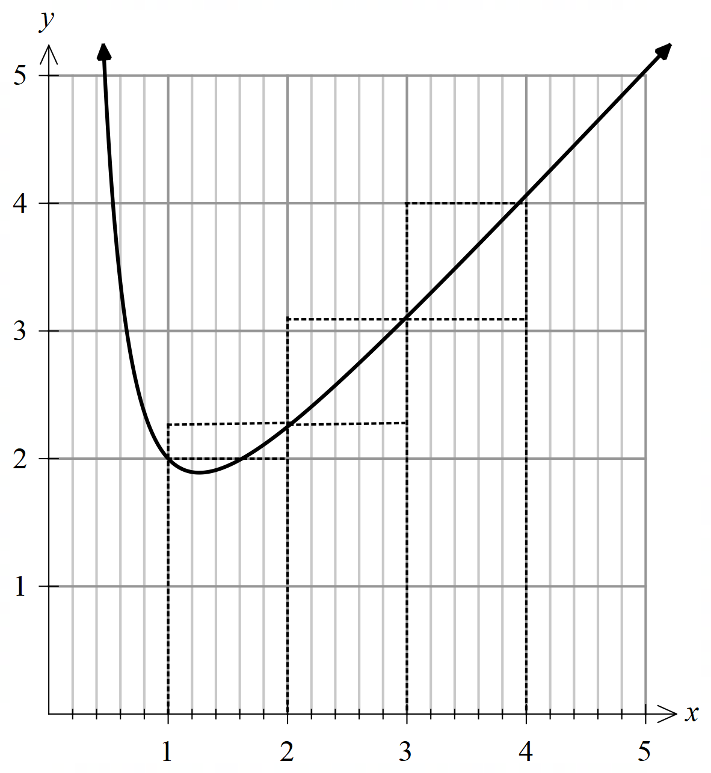

(a) Complete the table of values below expressing all answers as mixed numerals. (1 mark)

|  |  |  |  |  |
| --- | --- | --- | --- | --- |
| *x* | 1 | 2 | 3 | 4 |
|  | 2 |  |  |  |

(b) By considering the rectangles given

(i) show that  can be obtained as a lower estimate for the area under the curve from  to . (2 marks)

(ii) determine an upper estimate for the area under the curve from  to  in the form where *p* and *q* are integers. (2 marks)

1. Use your answers from part (b) to obtain a better estimate for the area under the curve

from  to  (1 mark)

(d) Determine the exact area under the curve  from  to  (1 mark)

**Question 14 (14 marks)**

The readership of print newspapers has seen a rapid decline in recent years. In one survey researchers collected data across Australia to analyse the readership of both print and digital media.

The data below shows readership results across 7 days for the biggest Australian newspaper publications (Mastheads). The data were published in 2018 and represent Australians aged over 14 years of age.

|  |  |  |  |
| --- | --- | --- | --- |
| **Cross-Platform Audience (Print & Online)** | | | |
| **All Publications**  **(Mastheads)** | **Print**  **Readership** | **Digital Readership** | **Total**  **Readership** |
|
|  | ‘000s | ‘000s | ‘000s |
| Australian Total | 6547 | 14 378 | 18 622 |

(a) In the table above explain why the entries in the Total Readership column are not the sum of the entries in the Print Readership and Digital Readership columns. (1 mark)

The following Australian data were also obtained for 2018.

|  |  |
| --- | --- |
| Estimated resident population 2018 | |
| Age (years) | Population |
| 0 -14 | 4 692 750 |
| Over 14 | 20 289 938 |
| Total | 24 982 688 |

The researchers reported that according to this data,

*“*32% *of all Australians aged over 14 read print media in the 7 day period.”*

(b) Show how the researchers obtained the value 32%. (2 marks)

A random sample of 10 Australians over 14 years of age was taken.

Let denote the number of people in this sample who read print media in the 7 day period.

(c) State the probability distribution of and the mean and variance of this distribution.

(3 marks)

(d) What is the probability, correct to four decimal places that

1. exactly 5 people read print media in the 7 day period? (1 mark)
2. there were more people that did read print media in the 7 day period than did not?

(2 marks)

1. the fourth person selected was just the second of the group to have read print

media? (2 marks)

Trial groups of 10 people from each of twenty randomly selected regions were selected.

(e) Determine the probability that within the twenty different regions less than 75% did not read print media. (3 marks)

**Question 15 (4 marks)**

(a) Determine . (2 marks)

(b) Hence or otherwise find a function *f(x)* such that

 (2 marks)

**Question 16 (5 marks)**

The velocity, metres per second, of a particle as a function of time, *t* seconds, is shown below. The function contains the points, (2,10), (6,10), (10,0), (12,-5), (24,-5) and (26,0).

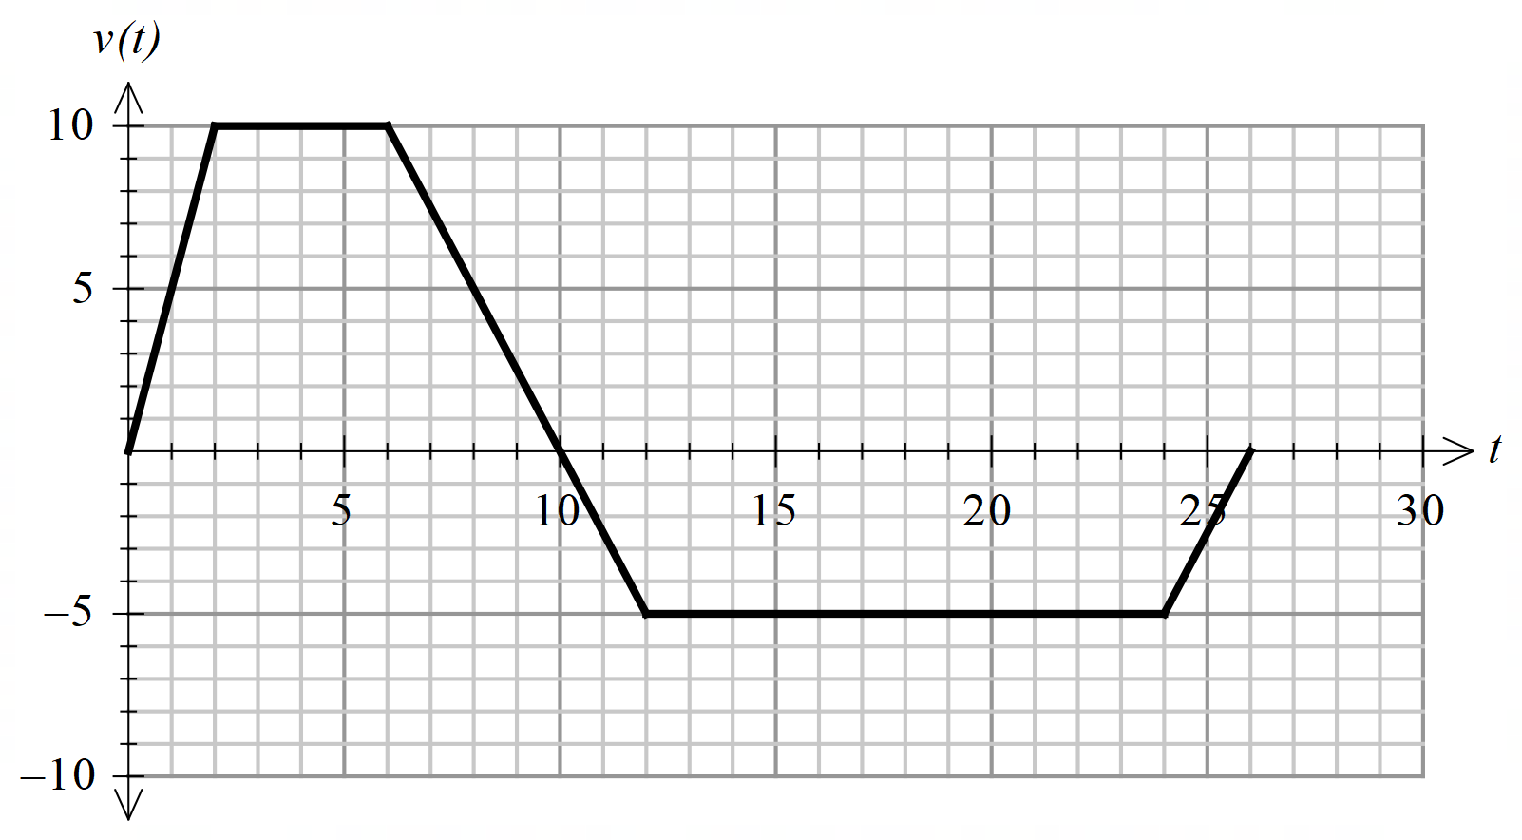

(a) What is the acceleration when *t* = 4 seconds? (1 mark)

(b) Determine the distance travelled in the first 6 seconds? (1 mark)

(c) State the displacement of the particle after 12 seconds. (1 mark)

(d) Determine the distance travelled in the first 12 seconds. (1 mark)

(e) At  is the particle slowing down or speeding up? (1 mark)

**Question 17 (14 marks)**

An unbiased spinner with 10 segments numbered from 1 to 10 is spun

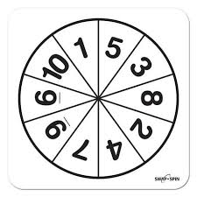

once. The random variable *Y* is recorded as a 1 if the result of the spin

is a prime number and as a 0 otherwise.

(a) Complete the probability distribution for *Y* shown below. (2 marks)

|  |  |  |
| --- | --- | --- |
| *y* | 0 | 1 |
| *P*(*Y=y*) |  |  |

(b) State the distribution of *Y* and its mean.(2 marks)

The game “Prime Time” is played at a fair and requires a contestant to spin the above spinner twice. The random variable *X* is defined as the number of prime numbers obtained in the two spins.

(c) State the possible values *X* can take. (1 mark)

(d) Determine the probability that *X* = 0. (1 mark)

(e) What is the most likely outcome for *X?*  Justify your answer. (3 marks)

To play “Prime Time”, contestants pay $5.00 to spin the spinner twice. If the player spins 0 or 2 prime numbers he wins $7.00. Otherwise he loses his money.

(f) In one day 500 contestants each play the game once. Calculate the expected gain or loss the game operator is likely to incur on this day. Explain your answer. (3 marks)

Over time the operator noticed that on a daily basis less people were playing the game. He decided to make an adjustment to the price he charged for a contestant to play.

A game is considered “*fair*” if in the long term neither the operator nor the contestant is expected to make a gain or loss.

(g) What price would the operator need to charge to play this game in order to make it “*fair*” without altering the rules or payouts? (2 marks)

**Question 18 (12 marks)**

The amount of daily sunlight (*S*) falling on a particular place on the Earth’s surface can be modelled by a sinusoidal function of the form:



where $S$ is the number of hours of daily sunlight  months after the beginning of the year, and and are constants.

Given that the daily amount of sunlight ranges from 9.5 hours through to 14.5 hours, and the maximum daily amount occurs 11.7 months after the beginning of the year,

(a) (i) explain why and . (3 marks)

(ii) use calculus to determine the value of  (3 marks)

1. Estimate the amount of sunlight that can be expected on April 30th. (1 mark)

1. Calculate the average daily amount of sunlight in May and June. (2 marks)

Note: the average value of a function $f$ in an interval is given by



1. Estimate using the increments formula the biggest change in consecutive days in the total daily sunlight. Give your answer correct to the nearest minute. (3 marks)

Note: for this purpose, you may assume that 1 day isof a month.

**Question 19 (11 marks)**

Consider the functions  and .

1. Let . Determine the smallest value of  where is a positive real number such that is undefined. (3 marks)

1. Determine, correct to two decimal places, the total area of the regions bounded by and the lines  and  (5 marks)
2. Determine where if the total area of the regions bounded by and the lines  and is one half the area of the regions described in (b) above.

(3 marks)

Supplementary page

Question number : ____________

Supplementary page

Question number : ____________

Supplementary page

Question number : ____________

**Acknowledgements**

**Question 11** Data source: Roy Morgan

Over 15.7 million Australians red newspapers in print or online

Retrieved 5th March 2020

<http://www.roymorgan.com/findings/7878-australian-newspaper-print->

Data source: Australian Bureau of Statistics

Australian Demographic Statistics, June 2019

Retrieved 5th March 2020

<https://www.abs.gov.au/AUSSTATS/abs@.nsf/DetailsPage/3235.02018?OpenDocument>

© MAWA, 2020

This examination is Copyright but may be freely used within the school that purchases this licence.

* The items that are contained in this examination are to be used solely in the school for which they are purchased.
* They are not to be shared in any manner with a school which has not purchased their own licence.
* The items and the solutions/marking keys are to be kept confidentially and not copied or made available to anyone who is not a teacher at the school. Teachers may give feedback to students in the form of showing them how the work is marked but students are not to retain a copy of the paper or the marking guide until the agreed release date stipulated in the purchasing agreement/licence.

*Published by The Mathematical Association of WA*

*12 Cobbler Place, MIRRABOOKA 6061*